EXPERIMENT 4
Missionaries and Cannibals Problem
Question
Write a Python program to solve the Missionaries and Cannibals problem.
Aim
To write a Python program to solve the Missionaries and Cannibals problem using the Breadth First Search (BFS) algorithm.
Algorithm
- Start with 3 missionaries and 3 cannibals on the left side of the river.
- The boat starts on the left side.
- Generate all possible combinations of missionaries and cannibals that can travel in the boat.
- Check whether the new state is safe.
- A state is safe when missionaries are not outnumbered by cannibals.
- Store the safe and unvisited states in a queue.
- Continue until all missionaries and cannibals reach the right side.
- Display the solution path.
Code
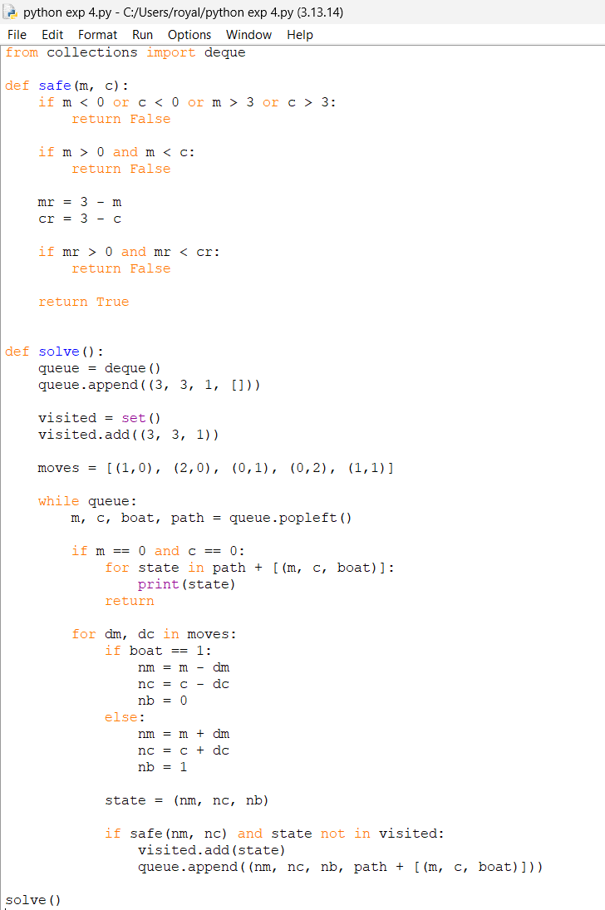
Output
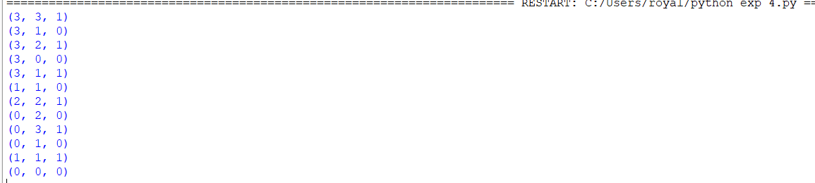

Result
Thus, the Missionaries and Cannibals problem was successfully solved using the Breadth First Search algorithm, and all missionaries and cannibals were safely transported to the other side.

